RECYCLING OF NEODYMIUM MAGNETS BY SELECTIVE ELECTRODEPOSITION

Student: Jeremy Lindh
Project Advisor: Mark De Guire
Case Western Reserve University
Department of Materials Science & Engineering
Dec 15, 2017

Recycling of Neodymium Magnets by Selective Electrodeposition

ABSTRACT

This paper explores a potential recycling route for neodymium-iron-boron alloy magnets via electrolytic separation of the neodymium from transition metal components. A procedure is proposed for the enrichment of iron in an electrodeposited metal from a dissolved mixture of iron and neodymium ions, and this is attempted and analyzed to determine the success of the method. The outcome of this attempt was inconclusive, due to insufficient analysis and unexpected developments in the chemical composition of the final electrodeposited material.

Recycling of Neodymium Magnets by Selective Electrodeposition

Introduction
Neodymium magnets compose a large portion of today’s permanent magnet market. They can be found in many consumer electronics such as computer hard drives, headphones, and cell phones.^{[1]} Their ubiquity is mainly due to their versatile strength as a magnet: Neodymium magnets exhibit a powerful magnetic field even when small, and can thus be used in a wide variety of magnetic applications.
Materially, neodymium permanent magnets consist of small grains of a neodymium-iron-boron alloy (composition approximately Nd₂Fe₁₄B) surrounded by a neodymium-rich matrix phase. This is made from a master alloy of the aforementioned composition that has been powdered and sintered together, forming a brittle intermetallic material. This is heated above a temperature referred to as the Curie temperature for the alloy, magnetized, and then cooled while still inside the magnetic field to align the magnetic moments along the direction of the applied field. The Curie temperature is the point at which all the magnetic domains of the alloy are mobile enough to either randomly orient in the absence of a magnetic field, removing the magnetic properties of the alloy, or align in the presence of a strong magnetic field, giving it the properties of a permanent magnet. The alloy’s high magnetic permeability, high magnetic moment per unit volume, and high coercivity results in a very strong magnet even at small sizes compared to traditional iron- and iron-oxide-based magnetic materials. During manufacture, other rare-earth materials can substitute for small amounts of the neodymium with little change in magnetic strength owing to their similar properties. Trace amounts of cobalt and nickel can be found substituting for iron in a similar manner.^{[2]} The average composition of the sintered body of a neodymium magnet is given below.
Table 1. Average composition of Nd sintered magnet by weight. Table adapted from Firdaus et al. (2016). O and C are listed as contaminants, and are therefore not compared during analysis.
Element | Composition (wt. %)
Nd | 23.00
Fe | 65.88
B | 0.99
Dy | 1.31
Pr | 6.97
Tb | -
Co | 0.99
Ni | -
Al | 0.25
O | 0.54
C | 0.07

After the alloy has been magnetized, it is coated in a suitably unreactive and mechanically stable metallic layer that resists degradation by oxygen and water as well as abrasion. Nickel, aluminum, and copper are typical choices for this coating.
Despite their wide use, no large-scale, economically viable process has yet been implemented to reuse neodymium-containing magnets. Most neodymium magnets in modern technology are quite small due to their proportionally high magnetic strength, and as such they are simply thrown away inside whatever product they were used in.
Concerns about availability of rare earth elements (including neodymium) have led to investigations into recycling of rare-earth metals in general. The current largest producer of rare-earths is China^{[8]} , which dominates the global trade mostly due to low prices, high demand, and high supply rates. However, if China were to raise the prices of rare earths, the electronics industry as a whole would suffer drastically due to the ubiquity of neodymium magnets and other rare-earths in magnetic, optical and modern energy storage technologies. For example, nickel-metal hydride batteries’ anodes consist of a variety of metal hydrides, several of which are rare-earths and one of which is neodymium. Doped yttrium-aluminum-garnet crystals (Nd:YAG) are used in laser optics. While the United States and other countries have reserves of rare earth materials, the companies have not been able to compete economically with China and have gone out of business. Recycling, therefore, would present a hedge against market manipulations by China, as well as being more ecologically benign than using only virgin rare earths.
Methods of reusing and recycling neodymium magnets are still in development, and many ideas exist on how to most efficiently and economically recycle the magnets that have already been manufactured. These methods can be categorized into pyrometallurgical, hydrometallurgical, and electrolytic techniques, using the descriptions provided by Firdaus et al. (2016).
Pyrometallurgical recycling takes place at higher temperatures, and is a desirable method when waste generation is an issue and water-based resources are scarce. Typical pyrometallurgical recycling methods include smelting the magnet scrap into a new master alloy for magnet production, separating transition metals and other materials from the desired rare earth metals, and high-temperature oxidation followed by reduction to extract the rare earth metals.
Hydrometallurgical recycling involves the use of traditional ‘wet chemical’ techniques to separate the rare earth materials from the transition metals. Because these reactions take place in aqueous solution, this method of recycling generates significant amounts of aqueous waste products. Hydrometallurgical recycling is also prone to longer reaction time than either pyrometallurgical or electrolytic.
An important subcategory of hydrometallurgical recycling is selective leaching, where a series of chemical treatments are used to selectively remove either Fe or Nd from aqueous solution without significantly affecting the other. This separation can be done using many chemicals, including alkali metal fluorides and neodymium-alkali sulfate double salts.^{[6]} Novel chemicals have also been developed specifically for this purpose, such as tri-nitroxide ligands.^{[7]} However, the complexity of these routes, and the cost of the reagents involved, often prevent them from being economically attractive.
Electrolytic recycling occurs when the magnet material is dissolved into solution (usually aqueous) and deposited back out via electric current. This method generates large amounts of liquid waste, and is the least cost-efficient of the three types owing to the number of steps and complexity of reagents used, as well as the relatively high cost of the electrical power needed to plate out significant amounts of material. It can be used to produce a new and highly pure ‘master alloy’ for the production of new neodymium-iron-boron magnets.
Electrolytic recycling can also be used in the inverse fashion; that is, plating out all impurities while leaving the neodymium and other desired compounds in solution. This can be achieved by holding the cell potential below that of the half-cell reaction potential of neodymium, and above the half-cell reaction potential of the transition metals and other impurities. These half-cell potentials are listed below:
Table 2. Half-cell potentials and Nernst equations for relevant reactions at concentrations of 10⁻¹ M for all species except H⁺ (from ^{[3,9]})
Reaction | Potential E°, V | Nernst Equation
Ce³⁺ + 3 e⁻ -> Ce | -2.34 V | E = -2.34 + 0.020(log[Ce³⁺])
Nd³⁺ + 3 e⁻ -> Nd | -2.32 V | E = -2.32 + 0.020(log[Nd³⁺])
Dy³⁺ + 3 e⁻ -> Dy | -2.30 V | E = -2.30 + 0.020(log[Dy³⁺])
Gd³⁺ + 3 e⁻ -> Gd | -2.28 V | E = -2.28 + 0.020(log[Gd³⁺])
Pr²⁺ + 2 e⁻ -> Pr | -2.00 V | E = -2.00 + 0.030(log[Pr²⁺])
Nd +3 H₂O -> Nd(OH)₃ + 3 H⁺ +3 e⁻ | -1.94 V | E = -1.94 - 0.060(log[H⁺])
H₃BO_{3(aq)} + 3 H⁺ + 3e⁻ -> B_{(s)} + 3 H₂O | -0.89 V | E = -0.89 - 0.060(log[H⁺])
Fe²⁺ + 2 e⁻ -> Fe | -0.447 V | E = -0.447 + 0.030(log[Fe²⁺])
Co²⁺ + 2 e⁻ -> Co | -0.28 V | E = -0.28 + 0.030(log[Co²⁺])
Ni²⁺ + 2 e⁻ -> Ni | -0.25 V | E = -0.25 + 0.030(log[Ni²⁺])
Cu²⁺ + 2 e⁻ -> Cu | +0.16 V | E = 0.16 + 0.030(log[Cu²⁺])

As can be seen from this table, applying a potential higher than 0.447 volts to a cell consisting of Nd³⁺, Fe²⁺ and B ions will cause the iron to plate out from solution onto the cathode (negative electrode) of the electrolytic cell, thus leaving the neodymium behind and enriching the electrolyte in neodymium ions. Note that the rare-earth elements all have a very similar (but generally slightly lower) reduction potential from their respective ions to neodymium itself, indicating that without very precise voltage control these elements would be significantly harder to separate from one another electrochemically from neodymium than iron would.
Another way of categorizing recycling processes is by the form of their end products. These can be split into alloy recycling, where the goal is a new, densified master alloy from which to make new magnets; material recycling, where the raw neodymium is separated in elemental form from the rest of the alloy to be reused in either magnets or other applications; and magnet recycling or magnet reuse, in which the magnets are directly reused in the shape they are in.
For our project, electrolytic material recycling was the selected method. While a pyrometallurgical method involving extraction with molten magnesium was initially considered, further inquiries determined that Case Western Reserve University did not have the proper setup to melt magnesium in a controlled and safe manner, so this route could not be pursued here. Selective electrodeposition was then chosen, with its main hazards being use of sulfuric acid (chosen because Nd could not passivate against it during electrolysis)^{[4]} and running high-current, low-voltage electricity through an aqueous electrolyte.

Procedure
A neodymium magnet was ordered from an online supplier. It had a plated surface, looking like nickel. Measuring 5.0 cm by 5.0 cm by 2.5 cm (for a total volume of 66 cm³), the magnet weighed 329.3 grams, corresponding to a density of 5.02 g/cm³. The magnet was heated to 315 ºC in an oven to remove most of the magnetization and thus make it safe to handle, even though the temperature used was at the lower end of the typical range of Curie temperature of a neodymium magnet (310-400 ºC).^{[10]} The temperature was kept relatively low to limit formation of Nd₂O₃, Fe₂O₃, and NdFeO₃.^{[5]} During this procedure, an unknown metallic material melted on the surface of the magnet, looking similar to the surface plating.
The first step was to dissolve a magnet in an acidic electrolyte, from which the non-rare-earth components could be plated out. The magnet was placed in a 1000-mL beaker with a stoichiometric amount of 98.3 wt.% sulfuric acid (507.8 g, or 276.0 mL) and an equal mass of distilled water according to the reaction:
Nd₂Fe₁₄B_{(s)} + 17 H₂SO_{4 (aq)} -> 14 FeSO_{4 (aq)} + Nd₂(SO₄)_{3 (aq)} + B_{(s)} + 17 H_{2(g)}
The beaker and its contents were heated on a hot plate to 80 ºC for several hours. Hydrogen gas evolved from the magnet surface as soon as it contacted the acid, and continued to do so for several hours. However, after some hours, dissolution stopped due to buildup of white precipitate in the reaction mixture, coating the magnet and preventing additional acid from contacting it. Measuring the pH of the mixture after this had occurred, it was found that the reaction solution was still highly acidic (pH<1), and thus the reaction could not have finished. This precipitate was mechanically removed by decantation of the liquid and washing of the precipitate out of the reaction vessel. However, this method of removal was unsuccessful at speeding up the dissolution of the magnet, as every few hours the amount of precipitate would build up again to the point where dissolution would stop.
To counteract this, an additional 224 mL of sulfuric acid was added in the event that a side reaction was consuming available acid. Then, the electrolyte was moved to a 2000 mL beaker, the remainder of which was filled with distilled water, in an attempt to dissolve any further precipitate. In addition, the magnet was placed on an inverted, submerged glass beaker inside the reaction beaker to prevent a buildup of precipitate from obstructing the magnet surface. However, this only delayed the precipitate buildup, and the idea was eventually discarded. Due to the lack of success of previous methods of dealing with the precipitate, it was decided that a raised temperature would lead to increased reaction speeds and higher solubility of the precipitate. Because the temperature was no longer closely regulated, the temperature control probe was removed and the surface temperature of the hot plate was increased to 150 ºC. The magnet was completely dissolved in a few hours, forming the electrolyte solution for the next step. This solution had a pH of well below 1.
Two electrodes were submerged in the solution, connected to a custom power supply capable of providing up to 32 volts and 10 amperes of DC power. At first, graphite was selected as both the cathode and anode material due to its resistance to the harshly acidic electrolyte and resistance to general chemical corrosion. However, initial tests with graphite electrodes at 1.4 volts DC suffered from low current (0.03 to 0.14 amperes at maximum) due to the high resistivity of this material. The graphite electrodes’ resistance was measured to be approximately 4 ohms each. In addition, dramatic mechanical erosion of the graphite anode occurred, presumably due to intercalation of electrolytic oxygen weakening the mechanical structure.^{[11]}
Ultimately, no significant plating occurred on these electrodes, and the choice of materials was changed to a neodymium-magnet anode and a steel cathode to lower cell resistivity and eliminate the consequences of corrosion of the anode. This increased the current sufficiently to allow for electroplating to occur, however, at 1.4 volts only a dark, coppery metallic substance plated out onto the cathode even after 24 hours of electrolysis. This was presumed to be the copper visibly present in the magnet’s coating. The voltage was increased to 1.5 volts, and a much darker black, metallic nodular material quickly began appearing at much larger volumes than the brown plate before it, showing significant deposition after just 4 hours. The average current during this time was kept around 0.5 amperes, though this varied between 0 and 3 amperes due to the electrodes being moved farther away to prevent the growth on the cathode from touching the anode and short-circuiting. The cathode deposit was allowed to plate out for 48 hours. By this point, the pH of the electrolyte had increased from well below 0 at the start to a final pH of 8, resulting in slight precipitation of what appeared by color to be iron (III) hydroxide in the liquid. During transfer of the metal deposit to the analysis station, oxygen in the air resulted in it rapidly oxidizing at the surface, turning brown-red in coloration as opposed to an initial metallic black.
Results
Scanning-electron microscopy with energy-dispersive x-ray spectroscopy (SEM–EDXS) was selected as a method of chemical analysis. In this procedure, a beam of electrons is fired at the target substance (coated in palladium to prevent buildup of static electron charge), generating x-rays characteristic of the elements in the specimen. This also provides a gray-scale image of the microstructure of the specimen, so lighter-weight elements appearing darker and vice versa. In this manner, both the microstructure and chemical composition of a substance can be determined.
Several locations in the electrodeposited material were analyzed. Table 3 gives each location’s composition, as well as the average composition by weight of these locations and the average magnet composition for comparison:
Table 3: Comparison of chemical composition of electrodeposited sample and neodymium magnet by weight.
Wt. % | Location 1 | Location 2 | Location 3 | Electrodeposited Sample (avg.) | Magnet
Fe | 60.20 | 61.49 | 74.16 | 65.28 | 65.88
Nd | 9.87 | 9.69 | 6.30 | 8.62 | 23.00
B | 0 | 0 | 0 | 0 | 0.99
Dy | 0 | 0 | 0 | 0 | 1.31
Pr | 2.57 | 2.48 | 1.54 | 2.20 | 6.97
Tb | 0 | 0 | 0 | 0 | -
Co | 0.54 | 0 | 0 | 0.18 | 0.99
Ni | 0.82 | 0.88 | 0.70 | 0.80 | -
Gd | 12.25 | 11.70 | 8.12 | 10.69 | 0
Ce | 13.75 | 13.76 | 9.18 | 12.23 | 0
Al | 0 | 0 | 0 | 0 | 0.25

As shown, the plating consisted of an unexpectedly high amount of cerium and gadolinium. There was no boron in the plating, meaning it had either not plated out at all or had already been depleted by the time the metal closest to the surface was depositing, and was present somewhere deeper within the cathode material. The microstructure appeared to have grains of an unknown, acicular crystalline material on the surface, which was found by SEM to consist chiefly of iron oxide. Figure 1 shows one of these crystals, along with the SEM elemental mappings organized by color.
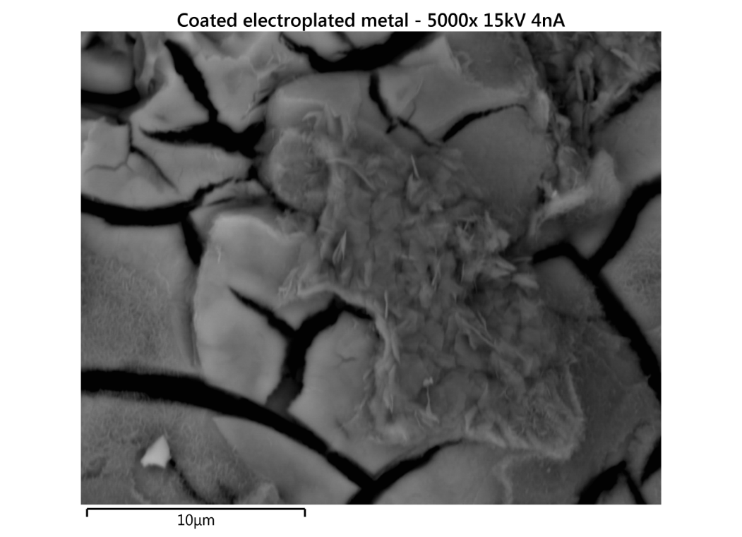
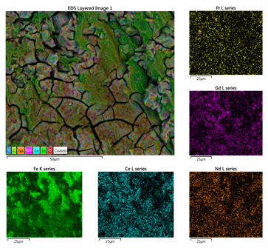
Figure 1. [caption]
Table 4 gives the composition of off-white precipitate, averaged from several sites.
Table 4. Chemical composition of white precipitate by weight.
Wt. % | White precipitate
Fe | 19.90
Nd | 6.07
B | 0
O | 38.53
Gd | 8.31
Ce | 6.08
Pr | 1.32
Al | 0.1
S | 15.86

No boron was detected in the precipitate, which consisted instead of a heterogenous mix of iron and rare-earth sulfate crystals (Figure 2):
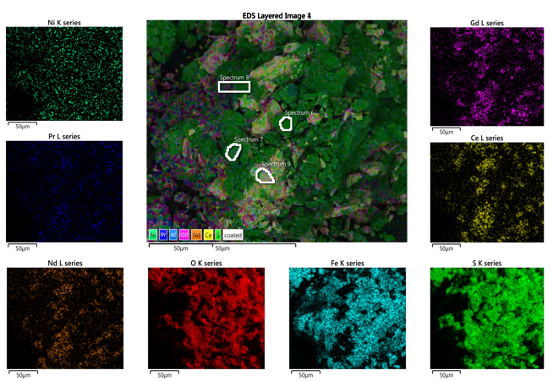
Figure 2. Spatial composition of white precipitate material. Iron sulfate crystals are depicted in green, rare-earth sulfate crystals in white.
(Boron, although a light element, is within the detection range of the EDXS unit used here.) These crystals had presumably precipitated out of solution at the reaction interface due to saturation of their respective ions in the solvent, the additional sulfuric acid producing yet more sulfate material from the magnet and thus driving precipitation forward. This could be rectified in the future by using much less concentrated reagents and a lesser amount of starting magnet material, allowing all ions to dissolve in the solution without much difficulty and removing the issue of precipitation entirely. Notably, aluminum is present in the precipitate but not in the electrolytic deposit, indicating that aluminum may have been present in the magnet’s coating and subsequently dissolved into the reaction mix.
Conclusion
While the ratio of iron to neodymium in the electrodeposited substance increased significantly (7.57:1 compared to 2.86:1 in a typical magnet), the ratio of total transition metals to total rare earth metals actually slightly decreased (1.96:1 compared to 2.14:1), meaning that the voltage selected actually enriched the cathode material in rare-earths rather than depleting them. Because it is difficult to tell at what precise overvoltage a metal will begin plating (for example, the oxidation of water to oxygen and hydroxides actually takes place at 1.23 V, even though the reduction of water to hydrogen takes place at 0.00 V by definition), it may be that the voltage selected was actually over the 2.34 V standard reduction potential to reduce Ce, Gd, and Nd alike. The unexpectedly high concentrations of gadolinium and cerium in the resulting cathode deposit may be due to the manufacturers of the magnet in question forgoing separation of these chemically similar elements before using the mixed-rare-earth metal in their production of the magnet material.
Several important questions were left unanswered by this analysis. The first is to explain what happened to the boron that was presumably present in the starting magnet. This could be done by extending the SEM analysis to a crystallized sample of the electrolyte liquid as well as the starting magnet. Given that no boron was detected in the white precipitate or the deposited metal, it would either have to be somewhere deeper in the cathode or in the liquid electrolyte.
The second unanswered question is in regards to the actual enrichment done by the electrolytic process. Because the final composition was so unlike the presumed initial composition (which is in itself an industrial average), the initial composition of the magnet would tell us more about what the process actually achieved. Presumably gadolinium and cerium were present in the initial magnet, as neither was added at any time during the electrolytic or analytical process.
A third and final question regards the unusual lack of copper seen in the chemical analysis, as well as the surprising presence of aluminum in the precipitate instead of in the deposited metal. A copper-like layer was noticeably visible on the underside of the magnet coating after dissolution of the underlying magnet material, and a thin layer of copper between the neodymium alloy and the nickel plating could be an explanation of this. Future work could investigate whether the copper, and by extension the boron and other low-potential elements could be deposited selectively at a lower voltage, thus explaining the lack of presence of these two expected elements in the analysis of the electrodeposited material’s outer layer.

References
^{[1]} Tanaka, M., et al. Chapter 255, "Recycling of rare earths from scrap". Handbook on the physics and chemistry of rare earths (2013): 159–211.
^{[2]} Firdaus, M., et al. "Review of high-temperature recovery of rare earth (Nd/Dy) from magnet waste." Journal of Sustainable Metallurgy 2.4 (2016): 276-295.
^{[3]} Prakash, V., et al. "Electrochemical recovery of rare earth elements from magnet scraps — a theoretical analysis." Rare Earths Industry: Technological, Economic, and Environmental Implications (2015): 335.
^{[4]} Sueptitz, R., et al. “Corrosion, passivation and breakdown of passivity of neodymium”. Corrosion Science (2010) 52: 886‐891.
^{[5]} Yoon, H., et al. “The Effect of Grinding and Roasting Conditions on the Selective Dissolution of Nd and Dy from NdFeB Magnet Scraps”. Metals (2015): 1306-1314.
^{[6]} Lyman, Jane W., and Glenn R. Palmer. Recycling of neodymium iron boron magnet scrap. US Department of the Interior, Bureau of Mines, 1993.
^{[7]} Dai, Alan X., et al. "Recycling of Neodymium and Dysprosium from Permanent Magnets." (2016).
^{[8]} Wang, Xibo, et al. “Production Forecast of China׳s Rare Earths Based on the Generalized Weng Model and Policy Recommendations.” Resources Policy, vol. 43, Mar. 2015, pp. 11–18., www.sciencedirect.com/science/article/pii/S0301420714000816.
^{[9]} Haynes, W M. CRC Handbook of Chemistry and Physics: A Ready-Reference Book of Chemical and Physical Data. Boca Raton: CRC Press, 2009. Print.
^{[10]} Kittel, Charles, and Paul McEuen. Introduction to Solid State Physics. 6th ed., John Wiley & Sons, 2015.
^{[11]} Nystrom, William A. “Electrolytic Degradation and Electrode Structure.” Journal of the Electrochemical Society, vol. 116, no. 1, 19 Aug. 1968, pp. 17–24. Electrochemical Society, doi:10.1149/1.2411746.

