**Benzodiazepine Synthesis and Rapid Toxicity Assay**

James T. Fletcher* and Grit Boriraj

Department of Chemistry, Creighton University, 2500 California Plaza, Omaha, NE 68178

jamesfletcher@creighton.edu

**Laboratory Documentation**

Contents Page

A. Student Handout 2-7

B. Postlab Questions 8-9

C. GC/MS Reaction Monitoring 10-12

D. 1H NMR Characterization 13

E. 13C NMR Characterization 14

F. Instructor Notes 15-16

G. List of Chemicals 17

H. Safety Hazards 17

**A.** **Student Handout**

**BENZODIAZEPINE SYNTHESIS AND TOXICITY ASSAY**

Textbook Reference: McMurry, J. **Organic Chemistry**, 7th ed., Brooks/Cole: Belmont, 2008, pp 702-703, 710-714.

Heterocycles are organic rings that contain at least one non-carbon atom such as oxygen, sulfur or nitrogen. Nitrogen-containing heterocycles are commonly found in small molecule therapeutics, examples of which include morphine, Viagra® and the anti-HIV medication AZT. Benzodiazepines are a class of heterocycles that consist of a benzene ring fused with a seven-atom ring, two atoms of which are nitrogen. Many common depressants such as Valium include benzodiazepine rings and are commonly prescribed as sleep aids and anti-anxiety drugs.



The benzodiazepine ring to be synthesized in this experiment is a regioisomer variant of the benzodiazepine ring system found in therapeutics such as Valium and Xanax. This complicated ring structure can be created from simple building blocks via a relatively complicated condensation reaction between 1,2-diaminobenzene and two equivalents of a ketone (Scheme 1).

**Scheme 1**. Proposed mechanism for the benzodiazepine-forming condensation reaction of this experiment (adopted from *Heterocycles* **2007**, *71*, 453-458).



When any new drug candidate is synthesized, it must undergo a series of trials to measure its overall toxicity as well as its therapeutic efficacy. One common laboratory technique used to first approximate toxicity is to perform a serial dilution assay against a relevant cell or organism. In such assays, the drug molecule is diluted over a wide range of concentrations and each concentration is assayed so that the minimum concentration of drug bioactivity can be identified (such as the lysing of red blood cells or the killing of a whole organism). This is commonly referred to as the minimum lethal dose. This allows highly toxic drug candidates to be identified before proceeding on to more advanced (and expensive) studies.

In this experiment, the principle of assaying for minimum lethal dose will be illustrated by performing a (rather limited) dilution toxicity assay for the benzodiazepine product against the common aquatic organism *Artemia salina.*

Pre-lab:

Read the relevant sections of your textbook and the discussion in this chapter. Prepare your lab notebook with the date, experiment title, purpose, references and draw the reaction you will perform. The table of reagents should include the MW, amount, moles, and relevant physical properties (such as density or melting point) of all chemicals used in the experiment. Calculate the MW and theoretical yield of the benzodiazepine product, and prepare flowcharts for both the synthesis and assay parts of this experiment.

During lab:

Record exactly what you do and observe as you perform the experiment. Record the exact amounts of each reagent used. **Caution**: As with all organic compounds of known or potential toxicity, the *ortho*-phenylenediamine reactant and benzodiazepine product should each be handled with care (avoiding contact with skin) and disposed of properly.

EXPERIMENTAL PROCEDURE:

SYNTHESIS

This reaction should be performed in a 20 mL screw cap vial with lid. To the vial, add a magnetic stir bar, 0.28 g *ortho*-phenylenediamine (also known as 1,2-diaminobenzene), 2 mL acetone and 0.05 g sulfamic acid catalyst. Secure the screw cap lid, and stir the reaction using a magnetic stirrer for 30 minutes at room temperature.

A small-scale extraction will be performed to isolate the crude product. Add 7 mL of water and 7 mL of dichloromethane to the vial, cap it tightly, and shake vigorously for a few seconds to separate water-soluble and organic-soluble reaction components. Use a pipette to transfer the organic layer to a 10 mL Erlenmeyer flask. Add a small amount of Na2SO4 to dry this layer, and filter the dried organic layer via gravity filtration through a fluted filter paper into a round bottom flask suitable for rotary evaporation. Rinse your drying agent and filter with an additional 3 mL of methylene chloride, and collect it into the round bottom flask with your product solution. Remove volatile solvents via rotary evaporation, and note the appearance of your crude reaction product. (Alternatively, if a rotary evaporator is not available, CH2Cl2 can be removed using a simple distillation apparatus.) If you do not see a significant amount of solid in your round bottom flask after removal of solvent, gently blow a stream of air over your product in the hood for one minute or until solidification occurs.

To purify this crude product, a process called trituration will be used. Trituration is the treatment of an oily or gummy material with a solvent that will dissolve any contaminants and help to solidify the desired product. To purify your crude product by trituration, add 1 mL of a 1:1 mixture of isopropanol:hexane and swirl the mixture for two minutes. Isolate the trituration-purified product via vacuum filtration using a Hirsch funnel. Be sure to air dry the products for at least five minutes on the Hirsch funnel before measuring its mass and melting point. Note the difference in appearance between the crude and purified products.

(The melting point of the purified product should be 137-139 oC.)

ASSAY FOR TOXICITY

The toxicity of the purified product towards the aquatic organism, *Artemia salina* (commonly referred to as brine shrimp or “Sea Monkeys”), will be evaluated by performing an abbreviated serial dilution assay. In this assay, aqueous 5% ethanol solutions of three different benzodiazepine concentrations will be evaluated.

This assay will be performed using the three 4.5 mL graduated reaction tubes from your micro kit. Add 10 mg of purified product to one tube, and add 5 mg of purified product to a second tube (the third tube will not receive any drug). Add 0.1 mL ethanol to each of the three tubes. Agitate each of the drug-containing tubes until all of the solid is fully dissolved. Finally, using a pipette, add a salt-water suspension of live brine shrimp to each of the tubes until they are filled to the 2 mL graduation mark. There should be at least a dozen (likely many more) brine shrimp in each of the tubes for the assay. When transferring your brine shrimp from the hatching flask into your assay tube, try not to collect your brine shrimp from the top of the container because it has a high concentration of dead eggs, which will complicate the viewing of your assay.

Observe the differences in the behavior of the brine shrimp in each of the assay tubes over the course of 30 minutes. Try to approximate the percentage of brine shrimp that are actively swimming relative to those with reduced motility (twitching in place or falling to the bottom of the tube) at five-minute intervals. What conclusion can be made regarding the minimum lethal dose of benzodiazepine for this organism based on the timeframe of this assay? What conclusion can be made regarding the toxicity of ethanol itself for this organism under the conditions of this assay?

Cleaning up:

Dispose of your unused benzodiazepine product and solutions in the designated waste bottle. You can use acetone to rinse any residues into the waste container. Dispose of your brine shrimp assay suspensions in the designated waste bottle. You can then wash the tubes out with soap and water in the sink.

**B. Suggested Postlab questions**

Q: Is the benzodiazepine product of this experiment chiral? If so, note any chiral centers with a * on a skeletal structure drawing of the molecule.

A: It has no chiral centers.

Q: If 3-pentanone was used in place of acetone, what would the product or products be? If multiple products are made, what is their isomeric relationship? Are any products chiral? If so, note any chiral centers with a * on your skeletal structure drawing(s).

A: Two enantiomer products would be formed with the following identity:



Q: If 2-butanone was used in place of acetone, what would the product or products be? If multiple products are made, what is their isomeric relationship? Are any products chiral? If so, note chiral centers with a * on your skeletal structure drawing(s).

A: Two regioisomer products would form, each made as a mixture of stereoisomers.



Q: Based on the provided GC/MS data, propose a likely impurity that was removed during the trituration purification process.

A: The diimine intermediate product.

Q: What would the initial concentration of benzodiazepine in 100% ethanol need to be if an assay was to be run as a 5 mg/mL in 2% aqueous ethanol?

A: (5 mg/mL) / (0.02 ethanol) = 250 mg/mL in 100% ethanol before dilution into water

Q: Why do you suppose that even the brine shrimp in the control tube with only 5% ethanol showed signs of decreased motility?

A: Because ethanol is a known central nervous system depressant and is toxic at high concentrations.

**C. GC/MS Monitoring of Reaction**







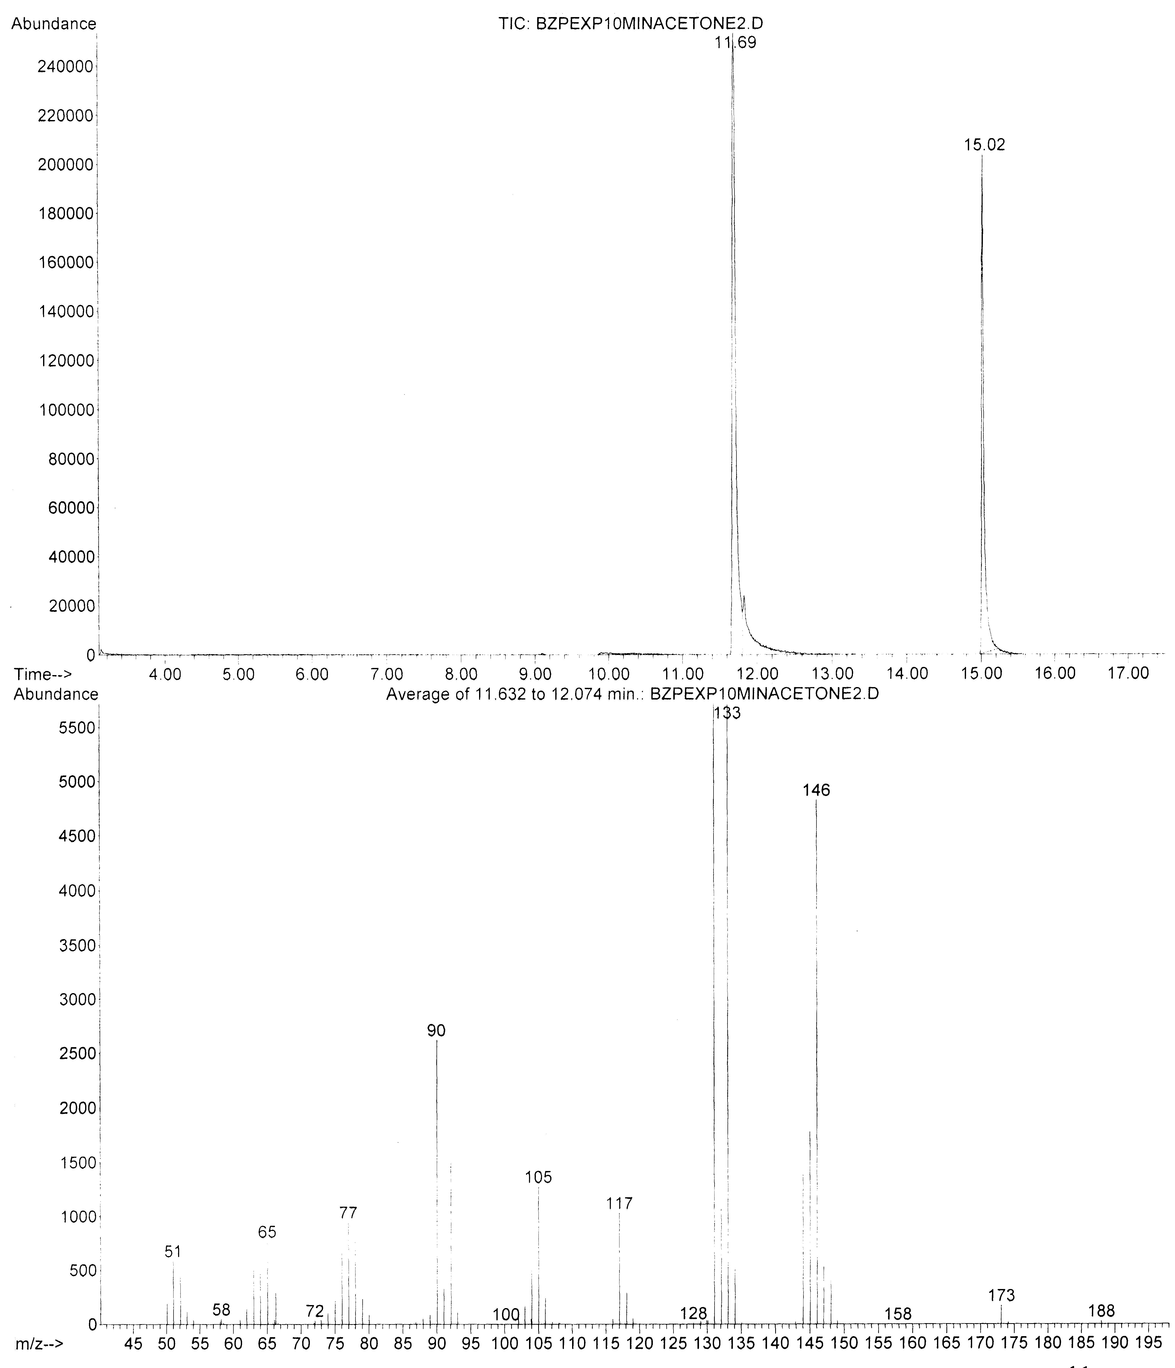

GC trace of product mixture after 10 minutes of reaction time (above), and mass spectrum (EI mode) of diimine intermediate product at 11.7 minutes GC retention time (below).

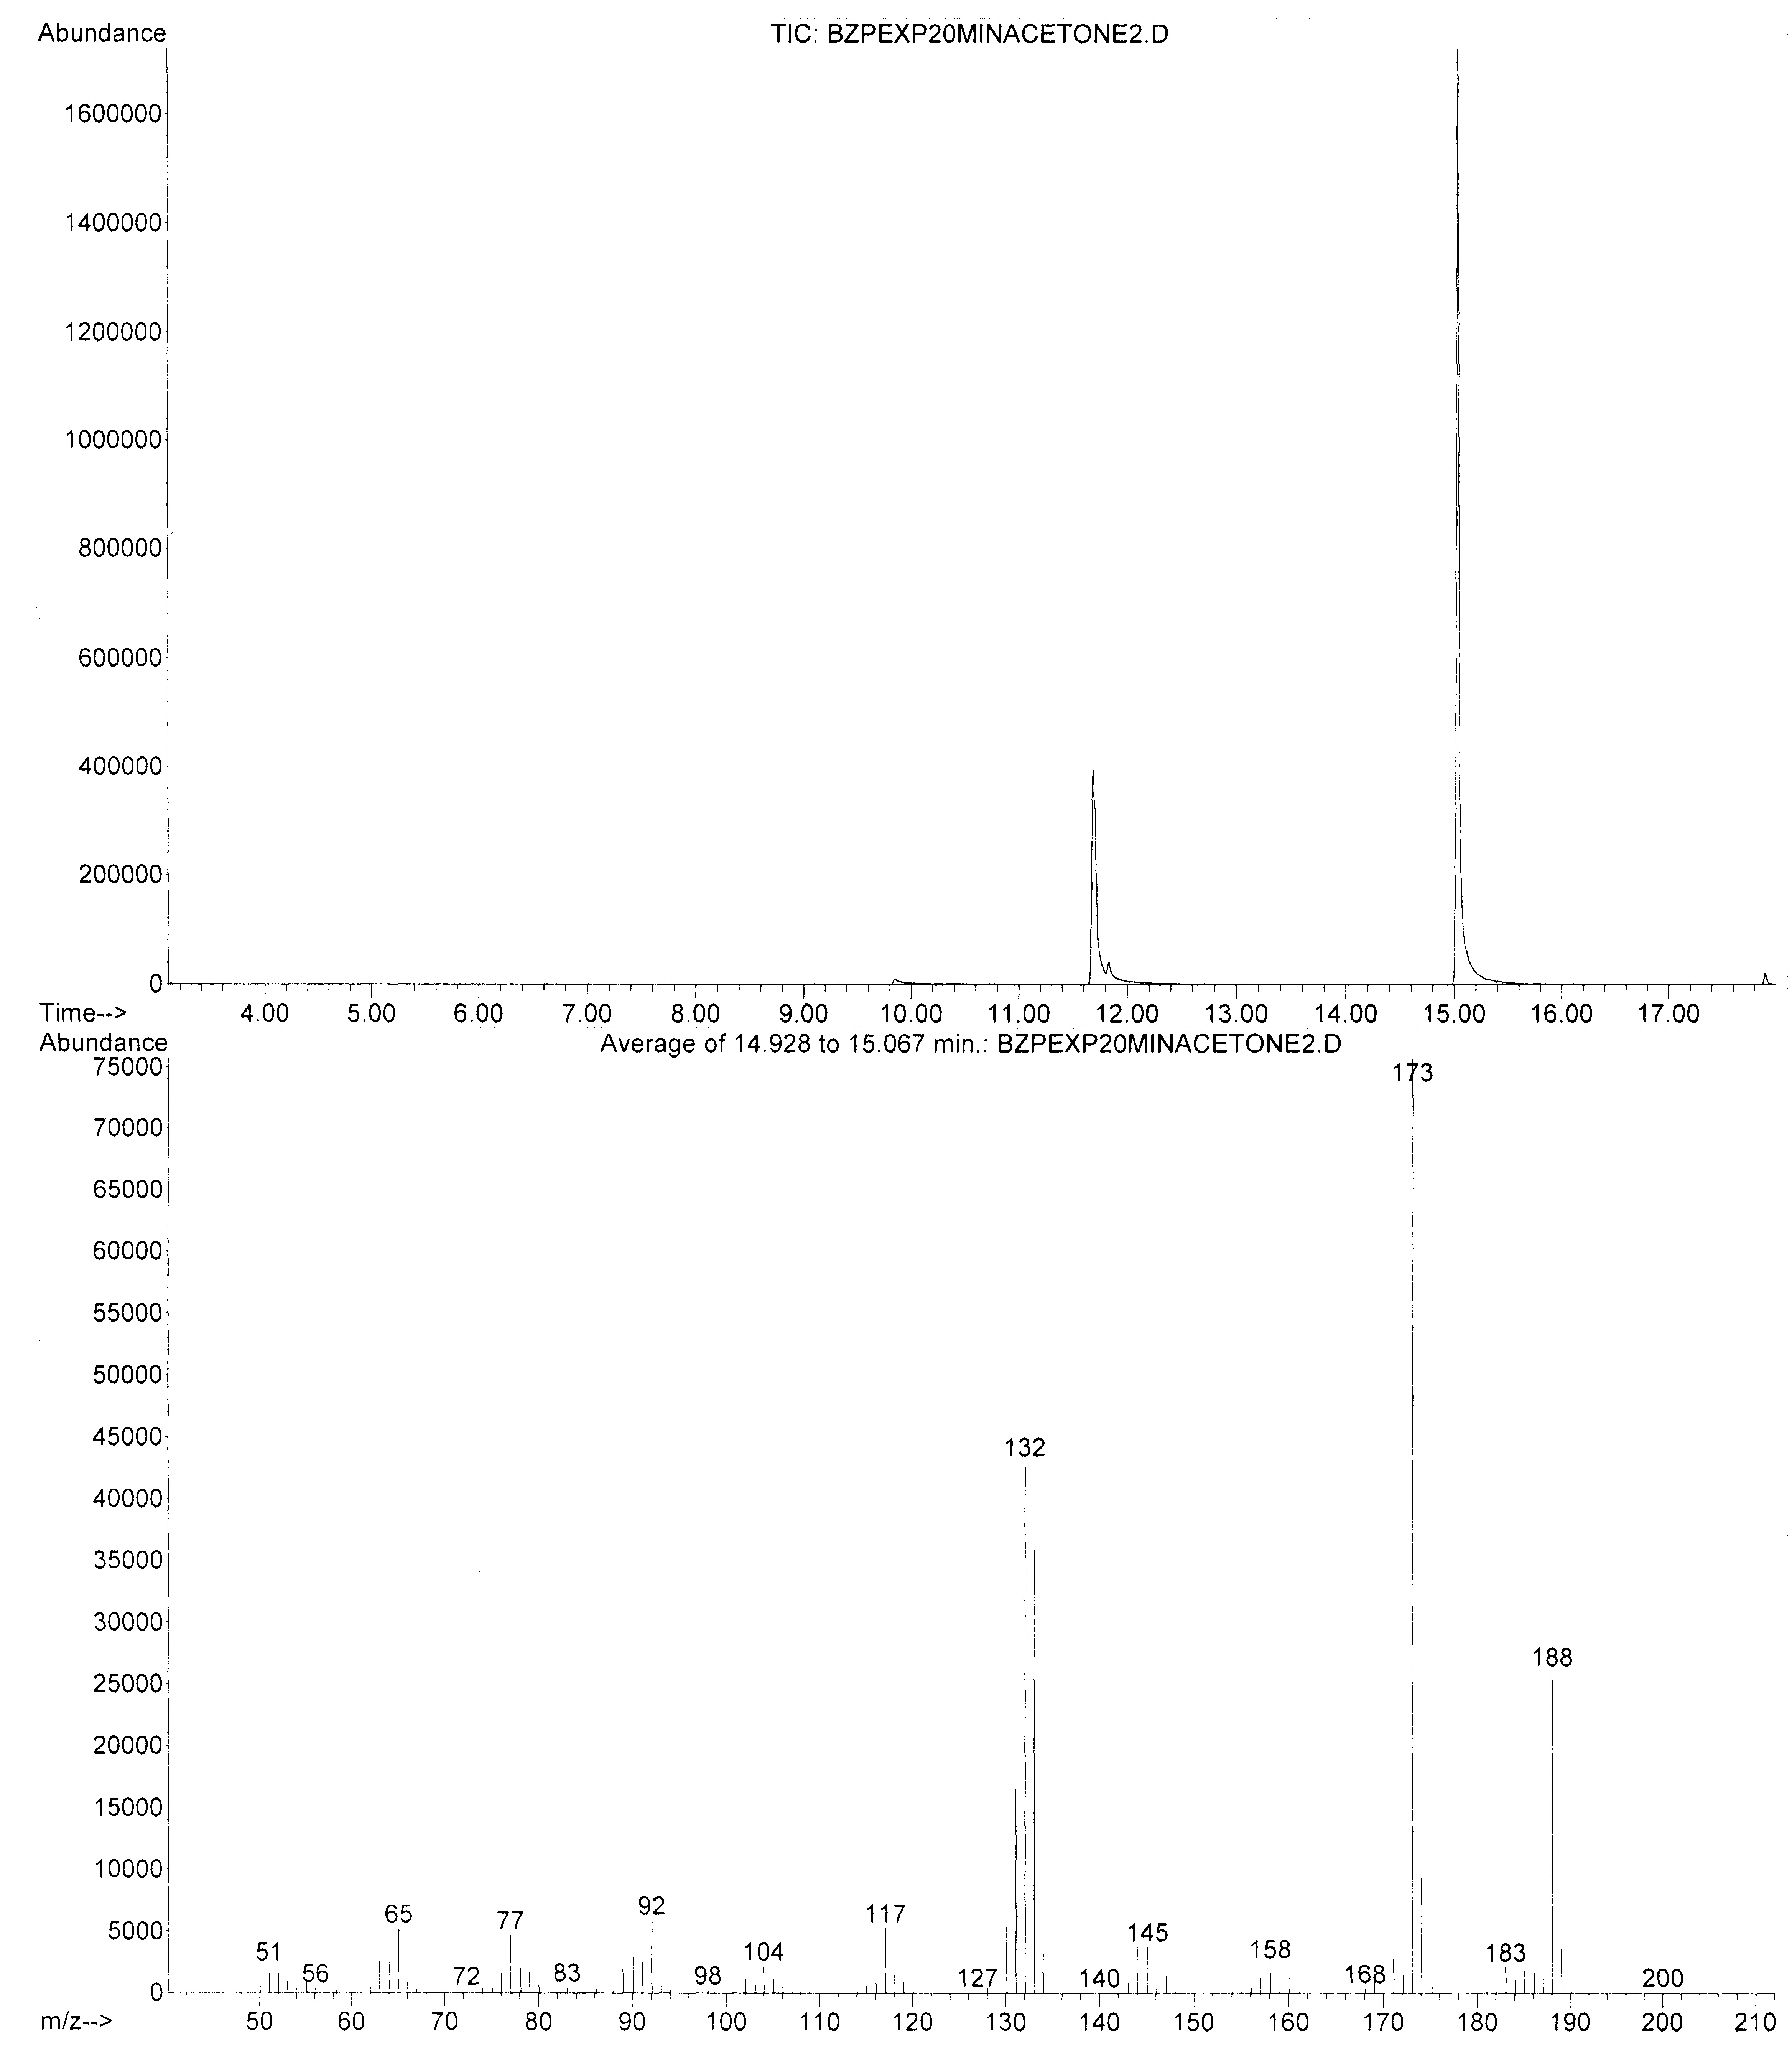

GC trace of product mixture after 20 minutes of reaction time (above), and mass spectrum (EI mode) of benzodiazepine product at 15.0 minutes GC retention time (below).

**D. 1H NMR of 2,3-dihydro-2,2,4-trimethyl-1H-1,5-benzodiazepine**

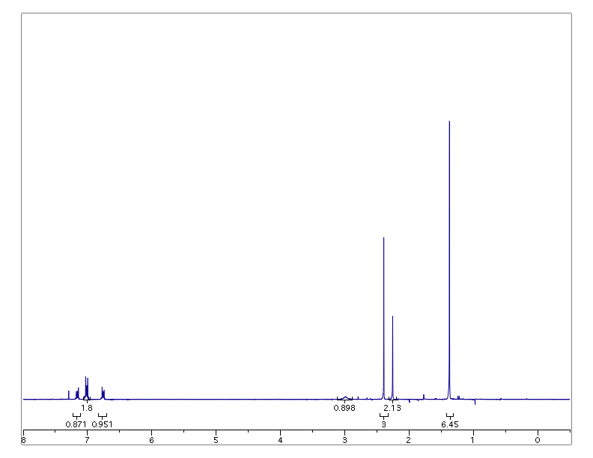

br s

CDCl­3 solvent

Key:

a b/c d e f g h



**E. 13C NMR of 2,3-dihydro-2,2,4-trimethyl-1H-1,5-benzodiazepine**

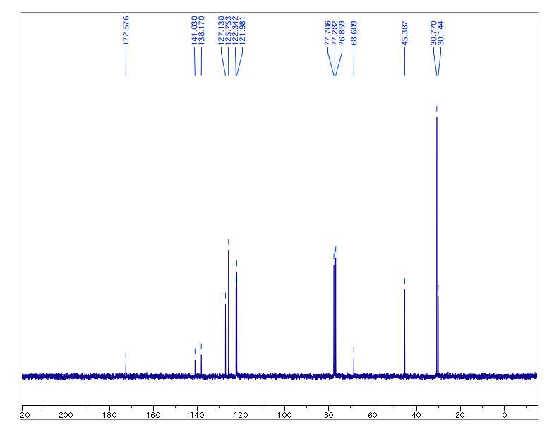

CDCl­3 solvent

Key: a b b bbbb c d e/f



**F. Instructor Notes**

Equipment needed to perform this experiment:

* + Lab balance capable of measuring to 0.001 g
  + 20 mL vials with screw caps
  + Stir bar
  + Stir plate
  + Disposable glass pipettes
  + 25 mL round bottom flask
  + Rotary evaporator
  + Hirsch funnel (or other for vacuum filtration)
  + Test tubes in the range of 2-5 mL volume
  + Aerator and heated aquarium (optional)

Optional equipment for product analysis:

* + Melting point apparatus
  + GC or GC/MS
  + NMR

Pre-Lab Preparation

Beyond acquisition and setup of all necessary equipment and chemicals, the hatching of the brine shrimp used for the bioassay must be initiated 36-48 hours in advance of the scheduled lab time. Freeze-dried brine shrimp eggs can be purchased at most pet stores (sold as fish food). Following package instructions, shrimp typically hatched within 36 hours and survived without food for an additional 24-36 hours.

Tips for success and troubleshooting

* If a small heated aquarium equipped with an aerator is not available, it was found that the brine shrimp can be successfully hatched at room temperature in a flask using simple aeration with a slow stream of house air introduced via tube and pipette. Brine shrimp lived only 24-36 hours after hatching (feeding only off of their egg sacks), so multiple rounds of hatching are necessary to coordinate with multiple lab sections with a more than two-day span.
* As the GC/MS data shows, students who did not wait the prescribed 30 minutes of time before working up their reactions obtained significantly lower product yields.
* Students who did not thoroughly perform their drying and evaporation steps obtained oily liquid crude products that did not successfully precipitate a solid product during the trituration process. Crude products should appear as solid or solid/oil mixtures before proceeding on to the trituration step. Blowing a slow stream of air onto oily crude products (in the hood) successfully solidified most crude product samples.
* The 100% ethanol stock solution for the higher concentration assay (100 mg/mL in ethanol) approaches the saturation limit, so students must be patient to ensure that all of their benzodiazepine has dissolved before diluting into the aqueous brine shrimp suspension.
* When mixing the ethanol stock solutions with the brine shrimp aqueous suspensions, it was much more efficient for students to add the smaller volume of ethanol to the assay tube first, followed by the addition of the larger volume of brine shrimp suspension to the assay tube second. Reversal of this order resulted in slowly diffusing layers of liquids with the narrow assay tubes used, leading to unreliable assay results.
* When properly set up, the majority of students observed obvious differences between their three assay samples within 15 minutes of observations.

**G. List of Chemicals**

Acetone (67-64-1)

Dicholormethane (75-09-2)

*Ortho*-phenylenediamine (95-54-5)

Sulfamic acid (5239-14-6)

Sodium sulfate (7757-82-6)

Hexanes (110-54-3)

Isopropanol (67-63-0)

Ethanol (64-17-5)

2,3-Dihydro-2,2,4-trimethyl-1H-1,5-benzodiazepine (24107-34-4)

**H. Safety Hazards**

*Ortho*-phenylenediamine is toxic. Acetone is toxic and flammable. Sulfamic acid is a corrosive solid. Dichloromethane is toxic. The benzodiazepine product should be considered toxic. All compounds should be handled in a manner consistent with their material safety data sheets, including proper hand and eye protection. All procedures should be performed using proper ventilation.