**Kinetics of the Reaction between Ethyl Chloroformate and Potassium *Iso*propyl Xanthate**

******* ******* *****

School: *** ***** ******

Grade: **

Age: **

Category: Chemistry

Advisor: Professor ****** ******

**Abstract:**

Bis[*iso*propoxy(thiocarbonyl)] sulfide, also known as *iso*propyl xanthic anhydride, serves as a useful precursor to other organosulfur compounds and is also commercially important as a flotation agent in ore processing. The reaction between potassium *iso*propyl xanthate and ethyl chloroformate in which it is produced has long been known, yet its mechanism and kinetics until now had never been studied in depth. The reaction kinetics are determined by monitoring of the concentrations of the reaction species over time under various initial conditions. The reaction is found to take place in two second order steps, in which one equivalent of potassium *iso*propyl xanthate first reacts with ethyl chloroformate to form the isolable intermediate *S*-ethoxycarbonyl-*O*-*iso*propyl dithiocarbonate, which then reacts with another equivalent of potassium *iso*propyl xanthate to form the final product. Mathematical models of the reaction system are presented, and the rate constants of both steps are determined.

------------------------------------------------------------------------------------------------------------

The author would like to thank Professor ****** ****** and the University of Minnesota Department of Chemistry for their assistance in providing facilities and materials suitable for this research.

**Table of Contents:**

1:------------------------------------------------------------------------------------Title Page

2: -----------------------------------------------------Abstract and Acknowledgements

3: -------------------------------------------------------------------------Table of Contents

4:--------------------------------------------------------------------------------Introduction

5: ----------------------------------------------Experimental Methods and Procedures

8: ------------------------------------------------------------------Results and Discussion

15: --------------------------------------------------------------------------------References

16:----------------------------------------------------------------Supplementary Material

**I: Introduction**

The reaction between potassium *iso*propyl xanthate and ethyl chloroformate has long been known, being first reported by Welde in 1877.[1] Its product, *iso*propyl xanthic anhydride, is used as a precursor for other organosulfur compounds,[2] for protection of amino acids in peptide synthesis,[5] and as a flotation agent in ore processing.[4] However, until now its mechanism had not been conclusively established. Previous evidence for *S*-ethoxycarbonyl-*O*-*iso*propyl dithiocarbonate as an intermediate compound comes from its being detected as an impurity in the crude reaction product.[2] The first step, then, was thought to be a simple nucleophilic acyl substitution, and this research confirms that conjecture. The mechanism of the second step, however, was less clear.

In order to determine the mechanism of both steps and enable the improvement of the yield, the kinetics of the reaction were studied by monitoring the concentration of the reaction species over time in several experiments, each with different parameters. In the first set of experiments, potassium *iso*propyl xanthate was reacted with a stoichiometric amount of ethyl chloroformate under conditions shown to give good yields and enable easy recovery of product, and thus used as a preparative method. In the next set, a twofold excess of ethyl chloroformate was used. Finally, to enable close study of the second reaction step, potassium *iso*propyl xanthate was reacted directly with *S*-ethoxycarbonyl-*O*-*iso*propyl dithiocarbonate in a third set of experiments.

The data support a mechanism in which both steps are second order, and enable the determination of rate constants. The knowledge of the kinetics of this important reaction not only sheds light on the mechanism, but also enables the prediction of the concentration of product over time given initial reactant concentrations, which will certainly prove useful in the course of optimizing the yield.

**II: Experimental Methods and Procedures**

The concentrations of *S*-ethoxycarbonyl-*O*-*iso*propyl dithiocarbonate and *iso*propyl xanthic anhydride were monitored over time under different initial conditions. Chemicals used were of ACS reagent grade, except potassium *iso*propyl xanthate and *S*-ethoxycarbonyl-*O*-*iso*propyl dithiocarbonate, which were produced according to the procedures given below. In all experiments a small amount of *iso*propyl xanthic disulfide was present, due to its being an impurity on the order of 0.5% in the potassium *iso*propyl xanthate starting material. However, this did not pose a problem for quantitation of the concentration of *iso*propyl xanthic anhydride, as the NMR spectra of the two compounds are sufficiently different. All reactions were carried out at room temperature unless stated otherwise. NMR spectra were taken on a 500 MHz Varian instrument with deuterated chloroform as the solvent. All of the experiments were carried out using a 3:2 mixture of methanol and water. Under these conditions, the *iso*propyl xanthic anhydride precipitates as a fine suspension, but the mixture can be considered homogenous for the purpose of determining concentration. In fact, the solvent was initially chosen for preparative methods to enable facile collection of *iso*propyl xanthic anhydride by filtration.

In the course of experimentation it was found that the amount of product collected at each time point was skewed downwards by mechanical losses during workup, which largely came from the product being absorbed by filter paper during removal of the drying agent. In theory, losses in this fashion are not dependent on amount of product, only on concentration of product in the extraction solvent. Therefore, it is possible to adjust for them by comparing the amount collected from the last small reaction sample and the amount collected from the final extraction of product.

For example, in Reaction 1, 0.972 g of organics were collected from the 25 mL removed at 55 minutes, and 26.22 g were collected from the 425 mL remaining at 60 minutes. Assuming the concentration varied little compared to the amount of mechanical losses during the intervening 5 minutes,

where is the amount of product lost. The amounts of mechanical losses for the other reactions were calculated in the same manner, and the concentrations presented here have been adjusted to account for mechanical losses. However, because mechanical losses are not completely constant, they remain the main source of error in the data. In future work, more solvent will probably be used for extraction to reduce this source of error.

**Reaction 1: Overall reaction (short timescale)**

Ethyl chloroformate (25 mL, 0.26 mol) was added with stirring to a solution of potassium *iso*propyl xanthate (91.5 g, 0.52 mol) in methanol (420 mL) and water (280 mL). Every five minutes for the next hour, 25 mL of reaction mixture were removed. Each portion was extracted with brine (20 mL) and diethyl ether (20 mL), dried with anhydrous MgSO4 (5g), and concentrated by rotary evaporation. At the end of the hour, the remaining reaction mixture was worked up in the same way, but with proportionately greater amounts (285 mL of brine and ether and 75 g drying agent).

**Reaction 2: Overall reaction (long timescale)**

Reaction 2 was performed using the same procedure as Reaction 1, except the reaction was sampled every 15 minutes and allowed to proceed for 4 hours.

**Reaction 3: 2x excess ethyl chloroformate**

Reaction 3 was performed using the same procedure as Reaction 1, except 50 mL of ethyl chloroformate were used.

**Reaction 4: 2x excess ethyl chloroformate, 4x dilution**

Reaction 4 was performed using the same procedure as Reaction 1, except 22.6 g potassium *iso*propyl xanthate and 12.5 mL of ethyl chloroformate were used, 50 mL of reaction mixture were removed at each time point and extracted with 40 mL brine and ether, and the reaction was monitored for 30 minutes.

**Reaction 5: 2x excess ethyl chloroformate, 20x dilution**

Reaction 5 was performed using the same procedure as Reaction 1, except 9.15 g potassium *iso*propyl xanthate and 5.00 mL of ethyl chloroformate were used, the reaction was carried out in twice the volume of solvent, 100 mL of reaction mixture were removed at each time point and extracted with 80 mL brine and ether, and the reaction was monitored for 30 minutes.

**Reaction 6: Second step reaction (short timescale)**

Reaction 6 was performed using the same procedure as Reaction 1, except 45.2 g potassium *iso*propyl xanthate were used, and the ethyl chloroformate was replaced by 54.15 g *S*-ethoxycarbonyl-*O*-*iso*propyl dithiocarbonate.

**Reaction 7: Second step reaction (medium timescale)**

Reaction 7 was performed using the same procedure as Reaction 1, except 45.2 g potassium *iso*propyl xanthate were used, the ethyl chloroformate was replaced by 54.15 g *S*-ethoxycarbonyl-*O*-*iso*propyl dithiocarbonate, and the reaction was sampled every 10 minutes and allowed to proceed for 2 hours.

**Preparation of potassium *iso*propyl xanthate**:

CS2 (484 mL, 8.01 mol) was slowly added over 10 minutes with vigorous stirring to a solution of KOH (436 g, 7.77 mol) in *iso*propanol (2.5 L) and water (100 mL) in an ice bath at 5 °C. The reaction mixture was stirred for an additional five minutes, after which the cream-colored precipitate which had formed was collected

by vacuum filtration on a Buchner funnel, washed with ethyl acetate (500 mL), and dried under vacuum overnight. Yield: 972.8 g (72%)

**Preparation of *S*-ethoxycarbonyl-*O*-*iso*propyl dithiocarbonate**:

Ethyl chloroformate (100 mL, 1.04 mol) was added all at once with stirring to a solution of potassium *iso*propyl xanthate (183 g, 1.04 mol) in *iso*propanol (980 mL) and water (420 mL) in an ice bath at 5 °C. Stirring continued for an additional two hours, after which the product was extracted into CHCl3 (1 L), washed with water (3 x 300 mL), dried with anhydrous MgSO4 (125 g) and concentrated by rotary evaporation to yield a yellow oil (180.3 g, 83%). [NMR δ 5.75 (septet, J = 6.2 Hz, 1 H), 4.32 (q, J = 7.1 Hz, 2 H), 1.45 (d, J = 6.2 Hz, 6 H), 1.33 (t, J = 7.1 Hz, 3 H)].

**III: Results and discussion**

The reaction between potassium *iso*propyl xanthate and ethyl chloroformate is proposed to take place in a two-step process. In the first step, one equivalent of potassium *iso*propyl xanthate reacts by nucleophilic acyl substitution with one equivalent of ethyl chloroformate to form the intermediate compound *S*-ethoxycarbonyl-*O*-*iso*propyl dithiocarbonate (Figure 1).

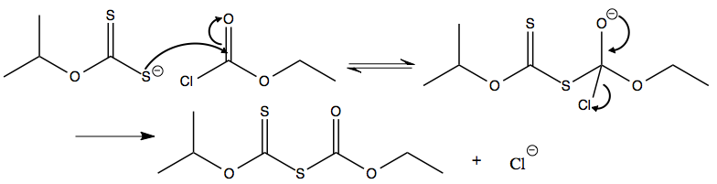

Figure 1

In the second step, the intermediate reacts with an additional equivalent of potassium *iso*propyl xanthate to form the final product. This step is proposed to be similar to a transesterification, except with an irreversible expulsion of carbonyl sulfide that drives the reaction forwards (Figure 2).

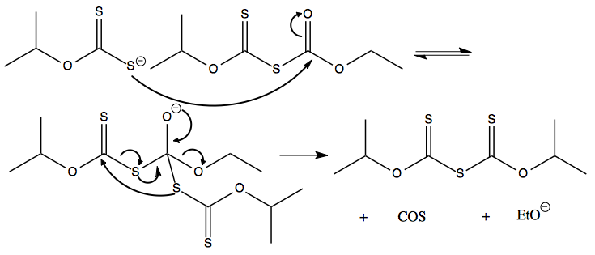

Figure 2

This mechanism predicts that the second step is slower than the first, since thioesters are less reactive than acid chlorides towards nucleophilic acyl substitution, and that both steps are second order overall. Thus, the rate law is:

where A is the concentration of potassium *iso*propyl xanthate, B is the concentration of ethyl chloroformate, C is the concentration of intermediate, and D is the concentration of final product. Taking note that

where and are the respective initial concentrations, the rate law can be rewritten:

This system of nonlinear differential equations is not analytically solvable, so numerical methods must be used. However, can easily be determined by direct reaction of intermediate with potassium *iso*propyl xanthate. In this case only step two of the overall reaction occurs, so the reaction is a simple second order one. The integrated rate law is thus:

The rate constant is easily computed by regression on the intermediate concentration with respect to time (Figure 3).



Figure 3

was found to be . Because is known, can also be found. The numerical integration of the system of differential equations was performed in Wolfram Mathematica, and was found by regression on the intermediate concentration to be (Figure 4).

**Predicted and Measured Intermediate Concentration vs. Time**

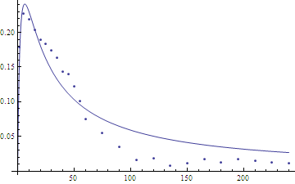

Figure 4

Concentration (mol/L)

Time (min)

While this model accurately predicts the intermediate concentration at early times, it overpredicts the concentration at late times (Figure 4), both in the overall reaction and in the direct reaction of intermediate with potassium *iso*propyl xanthate. This is probably due to the slow decomposition of intermediate by hydrolysis, which would most likely be a first order process.[3] Also, in calculating the concentration of isopropyl xanthic anhydride, the model assumes theoretical yields for the reaction, resulting in overprediction (Figure 5). To account for non-ideal yields, the predicted product concentration was scaled down by a factor of , which roughly corresponds with observed yields.

**Predicted and Measured *Iso*propyl Xanthic Anhydride Concentration vs. Time**

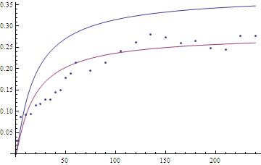

Concentration (mol/L)

Time(min)

Figure 5

The corresponding model in which the second step is first order was also considered. However, the predictions of this model do not agree with observations. The model predicts a slower initial rise of intermediate concentration in the overall reaction than that observed, and underpredicts the intermediate concentration for large times (Figure 6).

**First Order Predicted and Measured Intermediate Concentrations vs. Time**

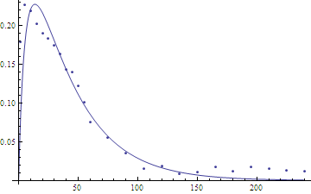

Figure 6

Time(min)

Concentration (mol/L)

While the overprediction of the second order model at large times can be explained by decomposition of the intermediate, there is no rational explanation for the underprediction of the first order model. Thus, it is clear that the observed intermediate concentration matches better with a second order model than with a first order one.

Also, when the reaction was diluted (in reactions 3, 4, and 5), the rate decreased by the square of the dilution factor. When the reaction was diluted by a factor of four, the rate decreased by a factor of ; when the reaction was diluted by a factor of twenty, the rate decreased by a factor of (Figure 7). This decrease in rate proportional to the square of the dilution further supports second order kinetics overall.

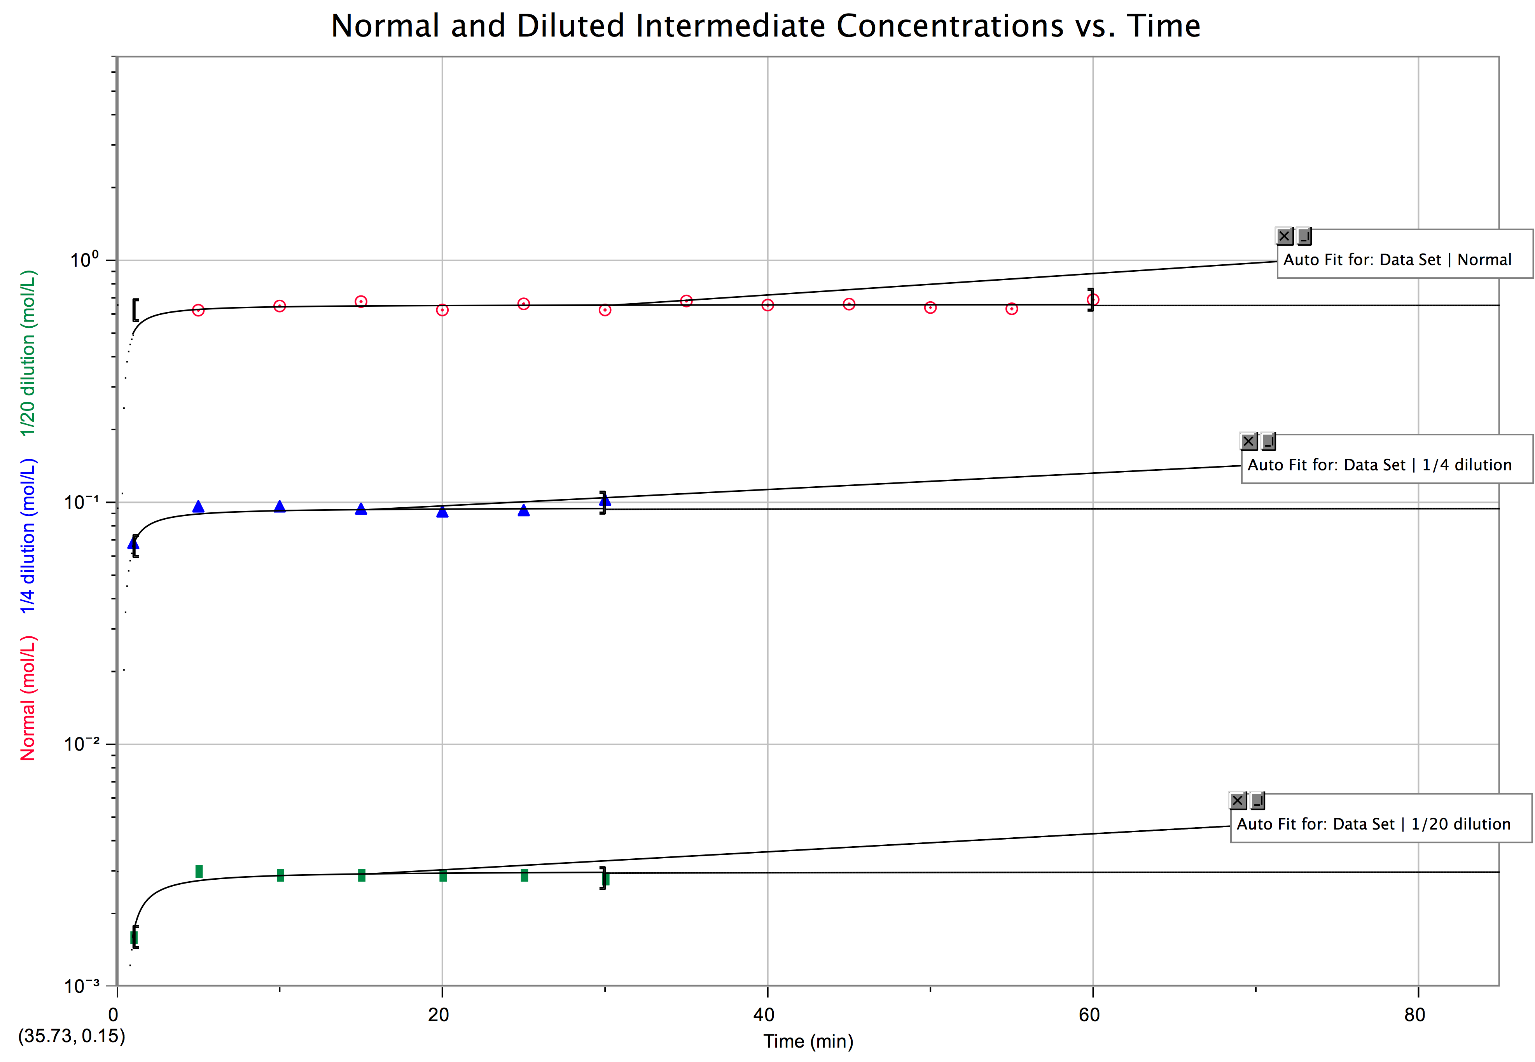

Figure 7

In conclusion, the reaction between ethyl chloroformate and potassium *iso*propyl xanthate is found to take place by a two-step mechanism in which both steps are second order. This supports the proposed mechanism, since nucleophilic acyl substitutions are known to be second order. The mathematical models presented accurately predict the concentrations of intermediate and product on short and medium timescales, but do not account for decomposition via hydrolysis. Therefore, more experimentation is needed to determine the rate of decomposition of intermediate. However, given that the target compound is reasonably stable under the reaction conditions employed,[3] decomposition is not likely to be a major issue for any preparative method based on this work.

**References:**

1: H. Welde, *J. Prakt. Chem.,* Vol. 15, 1877, pp. 42

2: Alayne L. Schroll, George Barany, Novel Symmetrical and Mixed Carbamoyl and

Amino Polysulfanes by Reactions of (Alkoxydichloromethyl)polysulfanyl Substrates with N-Methylaniline, J. Org. Chem., Vol. 51, Issue 10, 1986, pp. 1866–1881

3: Michael H. Jones, James T. Woodcock, Preparation, ultraviolet spectrophotometric

determination, and aqueous decomposition of alkyl xanthic anhydrides, *Analytica Chimica Acta,* Vol. 193, 1987, pp. 41-50

4: R. D. Crozier, Sulphide collector mineral bonding and the mechanism of flotation,

*Minerals Engineering*, Vol. 1991, pp. 839-858

5: George Barany, Bernard W. Fulpius, T. P. King, Convenient New Procedures for

the Synthesis of Ethoxythiocarbonyl Derivatives of Amino Acids, J. Org. Chem., Vol. 43, Issue 14, 1978, pp. 2930–2932

**Supplementary Material:**

**Concentration Data**

|  |  |  |  |
| --- | --- | --- | --- |
| **Reaction Number** | **Time (min)** | **Product concentration (mol/L)** | **Intermediate concentration (mol/L)** |
| 1 | 1 | 0.0311 | 0.1791 |
| 1 | 5 | 0.0872 | 0.2275 |
| 1 | 10 | 0.0921 | 0.2191 |
| 1 | 15 | 0.0941 | 0.2030 |
| 1 | 20 | 0.1140 | 0.1898 |
| 1 | 25 | 0.1170 | 0.1831 |
| 1 | 30 | 0.1282 | 0.1746 |
| 1 | 35 | 0.1279 | 0.1632 |
| 1 | 40 | 0.1440 | 0.1432 |
| 1 | 45 | 0.1495 | 0.1400 |
| 1 | 50 | 0.1782 | 0.1221 |
| 1 | 55 | 0.1889 | 0.1012 |
| 1 | 60 | 0.2138 | 0.0754 |
| 2 | 15 | 0.1105 | 0.1938 |
| 2 | 30 | 0.1618 | 0.1528 |
| 2 | 45 | 0.2067 | 0.0761 |
| 2 | 60 | 0.1923 | 0.0767 |
| 2 | 75 | 0.1956 | 0.0557 |
| 2 | 90 | 0.2139 | 0.0353 |
| 2 | 105 | 0.2410 | 0.0159 |
| 2 | 120 | 0.2619 | 0.0185 |
| 2 | 135 | 0.2812 | 0.0085 |
| 2 | 150 | 0.2735 | 0.0116 |
| 2 | 165 | 0.2600 | 0.0176 |
| 2 | 180 | 0.2651 | 0.0124 |
| 2 | 195 | 0.2476 | 0.0076 |
| 2 | 210 | 0.2440 | 0.0151 |
| 2 | 225 | 0.2763 | 0.0133 |
| 2 | 240 | 0.2770 | 0.0118 |
| 3 | 5 | 0.0348 | 0.6223 |
| 3 | 10 | 0.0202 | 0.6476 |
| 3 | 15 | 0.0000 | 0.6754 |
| 3 | 20 | 0.0107 | 0.6236 |
| 3 | 25 | 0.0115 | 0.6611 |
| 3 | 30 | 0.0135 | 0.6237 |
| 3 | 35 | 0.0092 | 0.6794 |
| 3 | 40 | 0.0087 | 0.6535 |
| 3 | 45 | 0.0133 | 0.6594 |
| 3 | 50 | 0.0076 | 0.6382 |
| 3 | 55 | 0.0121 | 0.6308 |
| 3 | 60 | 0.0074 | 0.6877 |
| 4 | 1 | 0.0001 | 0.0660 |
| 4 | 5 | 0.0023 | 0.0936 |
| 4 | 10 | 0.0044 | 0.0936 |
| 4 | 15 | 0.0060 | 0.0915 |
| 4 | 20 | 0.0071 | 0.0892 |
| 4 | 25 | 0.0068 | 0.0903 |
| 4 | 30 | 0.0088 | 0.0997 |
| 5 | 1 | 0.0000 | 0.0016 |
| 5 | 5 | 0.0002 | 0.0030 |
| 5 | 10 | 0.0003 | 0.0029 |
| 5 | 15 | 0.0004 | 0.0029 |
| 5 | 20 | 0.0006 | 0.0029 |
| 5 | 25 | 0.0006 | 0.0029 |
| 5 | 30 | 0.0006 | 0.0028 |
| 6 | 5 | 0.0435 | 0.2062 |
| 6 | 10 | 0.0487 | 0.1991 |
| 6 | 15 | 0.0617 | 0.1807 |
| 6 | 20 | 0.0761 | 0.1663 |
| 6 | 25 | 0.0890 | 0.1697 |
| 6 | 30 | 0.0942 | 0.1493 |
| 6 | 35 | 0.1038 | 0.1333 |
| 6 | 40 | 0.1234 | 0.1017 |
| 6 | 45 | 0.1425 | 0.1060 |
| 6 | 50 | 0.1830 | 0.0826 |
| 6 | 55 | 0.1951 | 0.0734 |
| 6 | 60 | 0.1950 | 0.0675 |
| 7 | 10 | 0.0806 | 0.3125 |
| 7 | 20 | 0.0807 | 0.3158 |
| 7 | 30 | 0.2108 | 0.1289 |
| 7 | 40 | 0.1842 | 0.1413 |
| 7 | 50 | 0.2353 | 0.0926 |
| 7 | 60 | 0.2647 | 0.0707 |
| 7 | 70 | 0.2801 | 0.0705 |
| 7 | 80 | 0.2923 | 0.0585 |
| 7 | 90 | 0.2896 | 0.0492 |
| 7 | 100 | 0.2974 | 0.0398 |
| 7 | 110 | 0.3078 | 0.0306 |
| 7 | 120 | 0.3240 | 0.0247 |